Asilo, Rainier

Mariano, Jorjo

2 ECE – A

**Machine Problem 1**

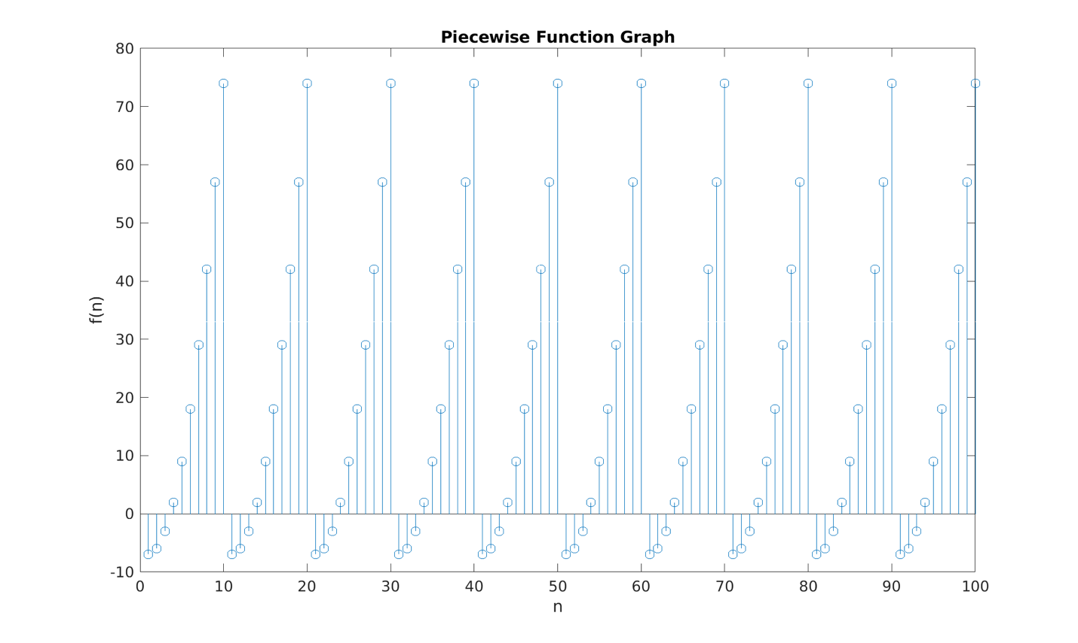

The first 10 values of n satisfy the first if statement of the code. And the succeeding values that is greater than 10 and lasts until 100 is then minus with 10, until it satisfies the first if statement of the code. That’s why the graph is repeated 10 times, because the graph is based on the first if statement and the 10 values were also repeated 10 times.